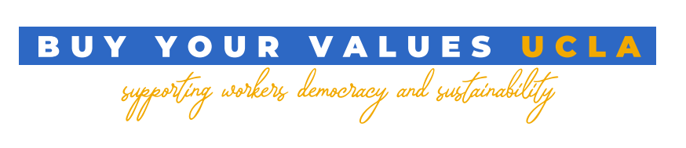
Letter of Support for the Buy Your Values UCLA Campaign

March 2022

We are a student-driven campaign that is pushing our student stores to stock socially responsible UCLA branded apparel and merchandise that are better for workers and for the environment, and that better reflect our ethical values as students. In addition, we want to establish a clear and enforceable code of conduct that these manufacturers have to abide by, whether by union representation, cooperative ownership, small-batch/local manufacturing, or circular production.

The current partnerships consist of the Collection, a network of values-based textile companies and worker-run cooperatives located in North Carolina that produce and source sustainable materials from US farming associations or local recycled fabric; Unionwear, a unionized Newark, New Jersey-based company promoting small-batch manufacturing; Ethix Merch, a worker & environmentally-friendly promotional products company to handle promotion and distribution; and Equal Exchange, a global brand who pioneered Fair Trade coffee & chocolate and work closely with small farmers & cooperatives across the Global South, promoting fair prices & workers’ rights.

The campaign’s goals are as follows:
- To facilitate a partnership between UCLA licensing, retailers of UCLA collegiate licensed products, and trusted ethical manufacturers who follow the university’s Code of Conduct, to provide merchandise options to campus members that better guarantee the health and safety of workers, and that utilize more sustainable production models and that better reflect our values as students.
- To secure a license for these ethical manufacturers with UCLA’s licensing department so the UCLA Store and Campus Store can offer these ethically produced products.
- To connect student organizations directly with individual workers across the planet who produce UCLA branded merchandise, to ensure that their lives are not impacted by the exploitation rampant in the global garment industry and food economy.

The following UCLA student, faculty and progressive organizations hereby affirm their support for the Buy Your Values UCLA campaign, an initiative to make official collegiate licensed products available to the UCLA community that offer a greater emphasis on sustainability, worker democracy, and worker empowerment than the currently available options.

Garment Worker Center
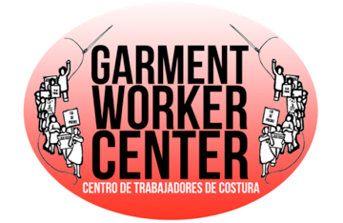
Refine LA

Student Labor Advocacy Project
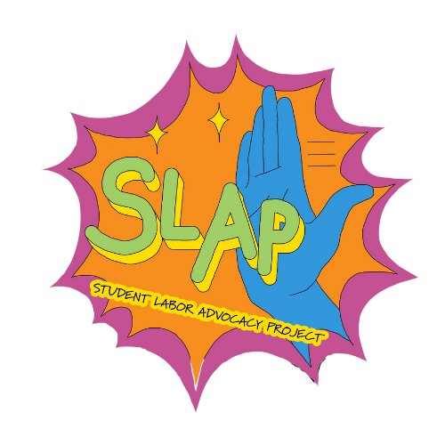

Environmentalists of Color Collective
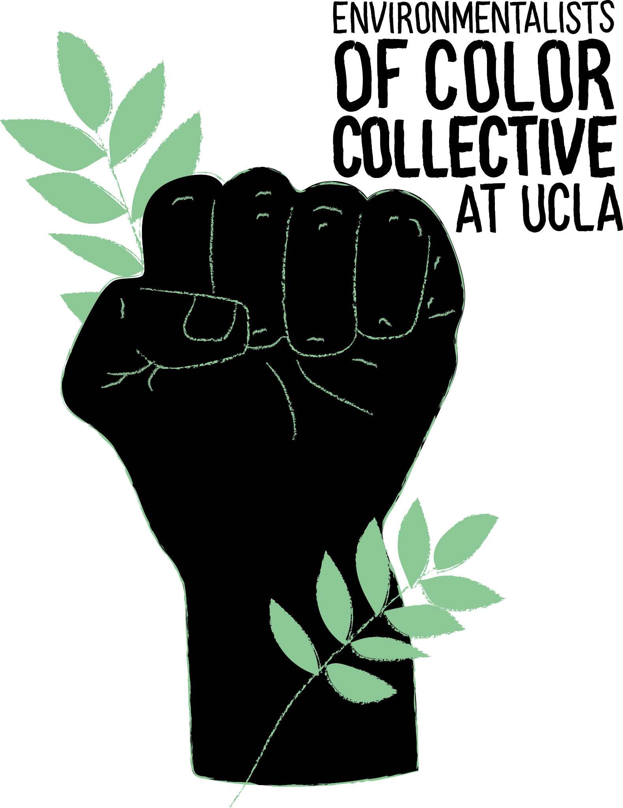

Young Democratic Socialists of America
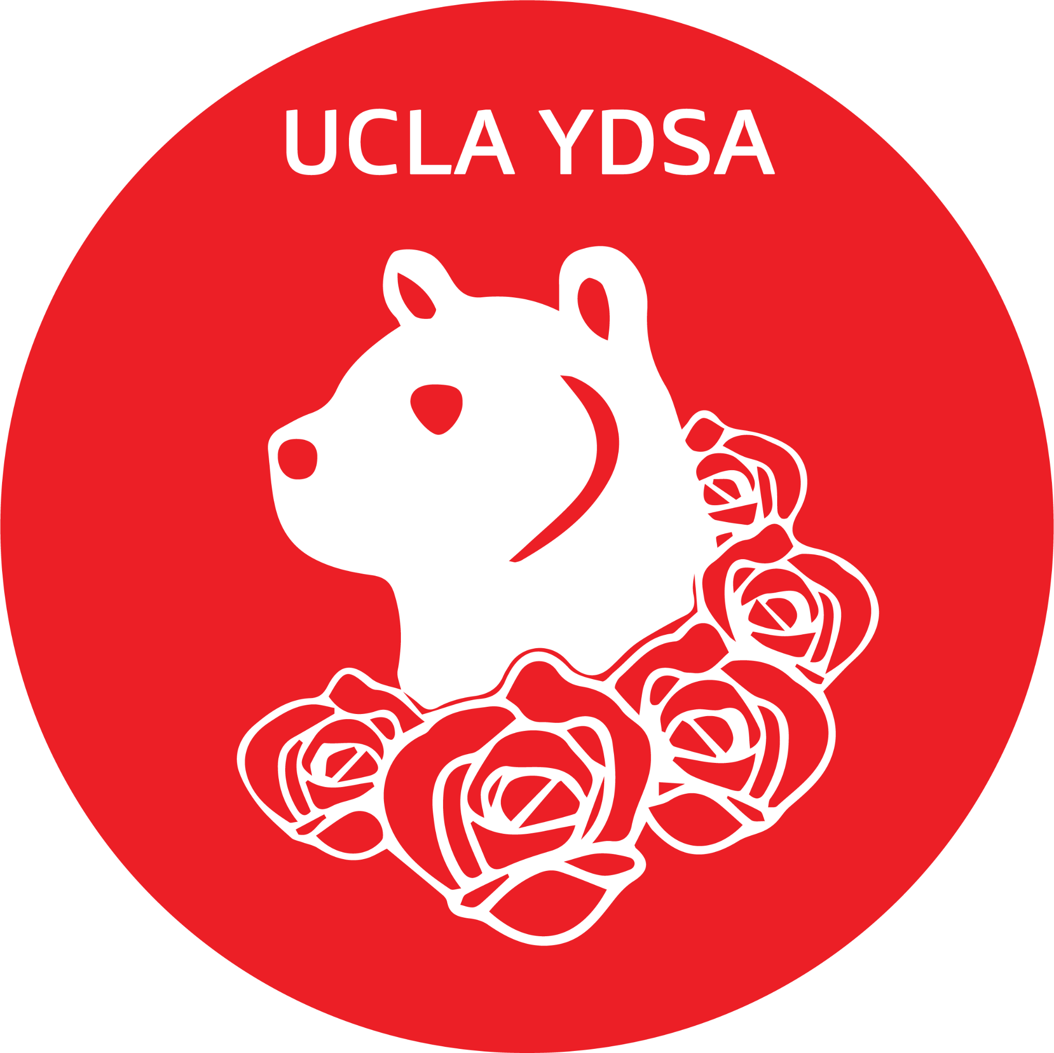

USAC Facilities Commission
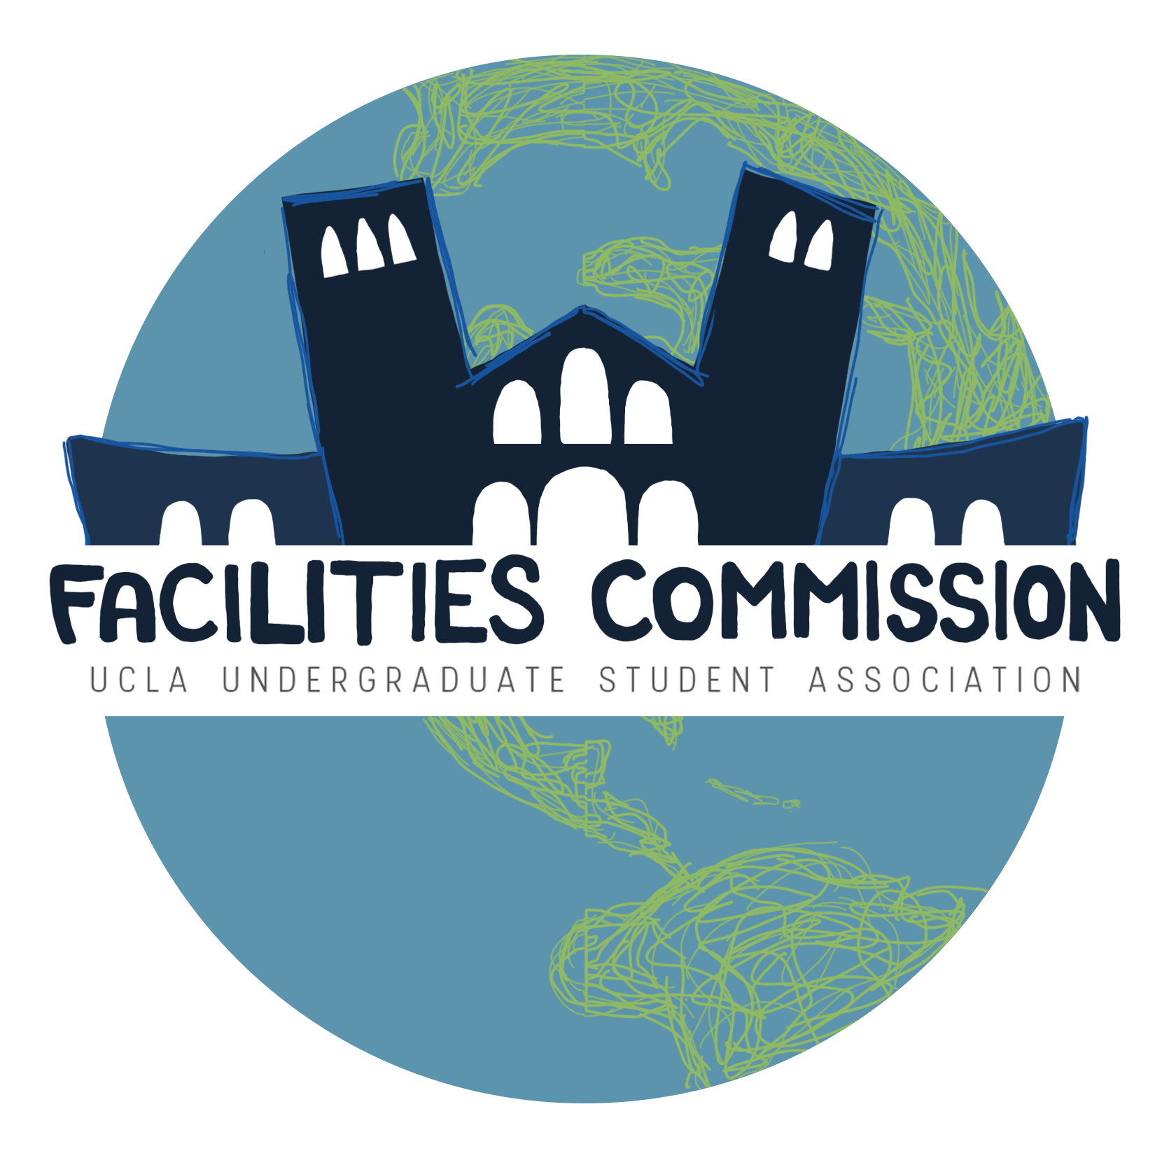

Unravel
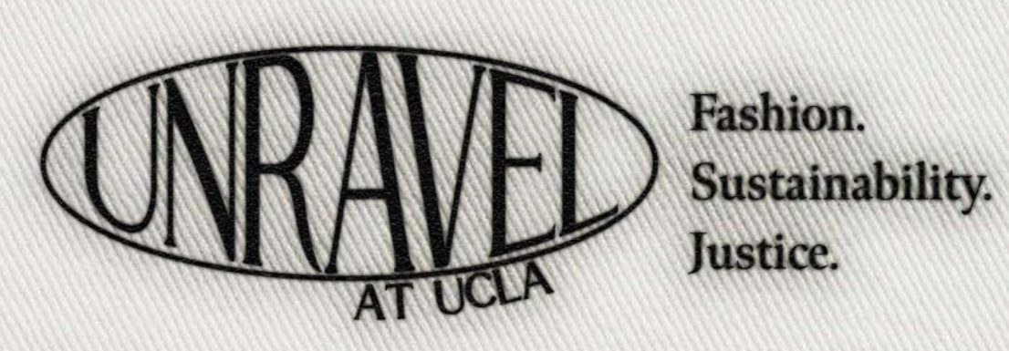

USAC:
- USAC Office of the President
- USAC Office of the External Vice President
- USAC Office of the Internal Vice President
- USAC General Representative 1
- USAC General Representative 2
- USAC General Representative 3
- USAC Transfer Student Representative
- USAC International Student Representative
- USAC Financial Supports Commission
- USAC Academic Affairs Commission
- USAC Community Service Commission
- USAC Cultural Affairs Commission
- USAC Campus Events Commission
- USAC Student Wellness Commission

